CLASSIFIED
Copy _____ of _____
Armor and Mechanized Infantry Task Unit
(Ranger Augmented)
1st Battalion, 7th Cavalry Regiment
1st Armored Brigade Combat Team
1st Cavalry Division
192000CMAY18

OPERATIONS ORDER (OPORD):
JUNIPER SPEAR
(OJS 2-9, TBD)
BATTALION TO TASK UNIT OPERATIONS ORDER
REFERENCES:
- Location of Umar (Primary Objective)
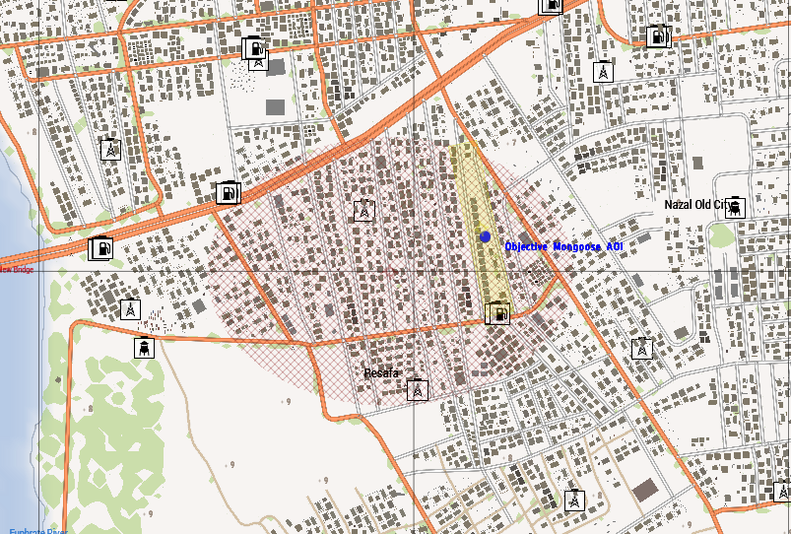
- Area of Interest
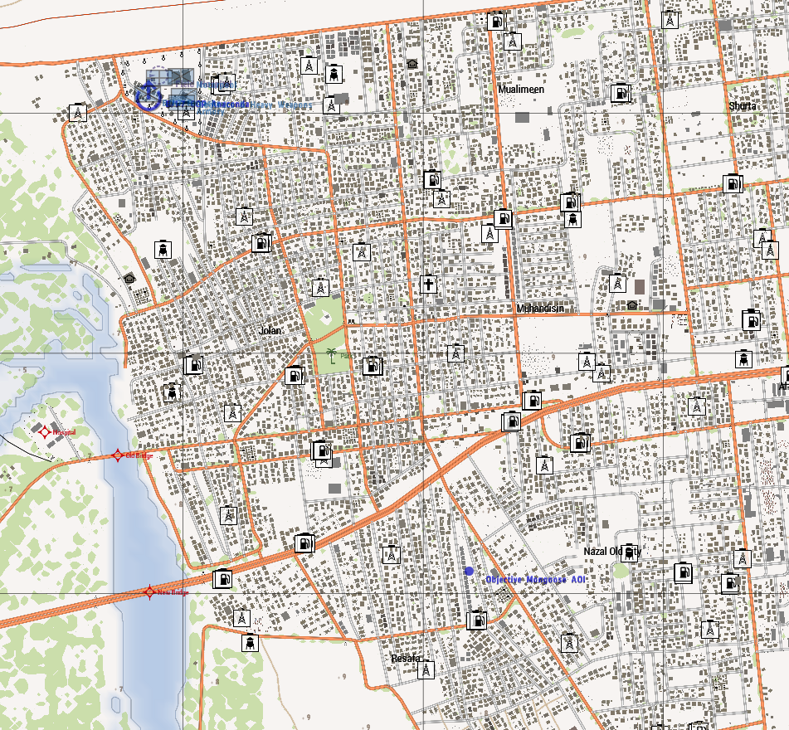
- Ranger Start Location
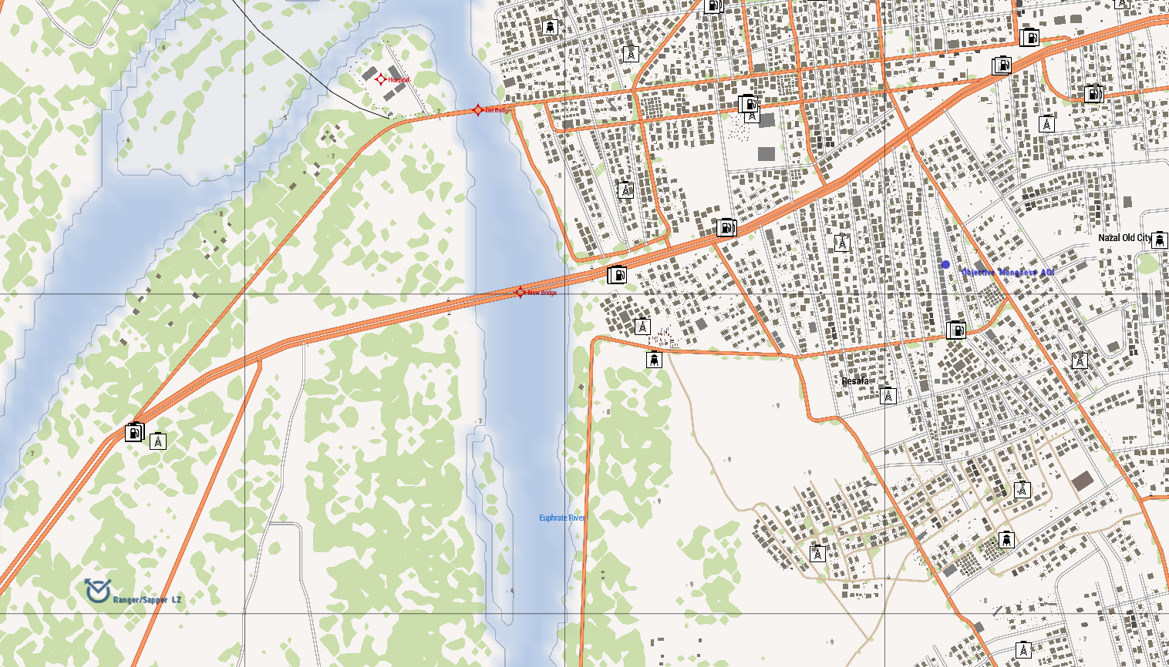
Task Organization:
Armored and Mechanized Infantry Task Unit:
TBD
- Situation.
XXXXXXX
  - Enemy Forces.
    - Weather and light data general forecast for the length of the operation:
High Temp: 30 Celsius
Low Temp: 24 Celsius
Sunrise: 0300 Z+3
Sunset: 1900Z+3
Overall Weather: CLEAR, SUNNY
Illumination (Night): HIGH
    - Terrain (OCAKA):
      - Observation and Fields of Fire (FOF) are limited for BLUFOR due to MOUT conditions. OPFOR has barricaded all roads leading in and out of the objective areas and encampment, as well as garrisoned buildings and terrain surrounding it.
      - Cover and Concealment is optimal for OPFOR entrenched in and around the objectives, given the MOUT environment.
      - Obstacles have been setup blocking the roads leading in and out of the objectives. OPFOR may have also setup ambush points, as well as IEDs, VIEDs, and suicide bombers.
      - Key or Decisive Terrain for this mission are the compounds at the objective. The objective is heavily fortified, and reinforced with mechanized, motorized, and CSW assets.
      - Avenues of Approach for OPFOR are _________ in the event they are able to rally and reinforce, or counterattack.
    - Identification of enemy forces (composition). OPFOR is equipped with crew served weapons, along with mechanized and motorized assets.
    - Location(s):
      - Phase Line Green (BLUFOR FLOT)
Center Grid: XXX-XXX
      - Phase Line Red (OPFOR FLOT)
Center Grid: XXX-XXX
      - TBD
Grid: XXX-XXX

    - Activity: OPFOR is garrisoned in and around the objectives, along with blockading likely avenues of approach. Any attempts to attack and occupy the objectives will likely be ambushed. OPFOR are reinforced by CSW and ....
    - Strength: OPFOR current strength estimates place it at around ....
    - Probable course(s) of action when contacted: OPFOR will likely remain in place and fight, and may attempt to counter-attack, and or make first contact through an ambush. Given relatively low morale, if decisively engaged, they will fight to the death, and likely not to surrender.
  - Friendly Forces.
    - Mission and concept of next higher unit: The Armored and Mechanized Task Unit assigned to 1st Battalion, 7th Cavalry will ...
    - Location and planned actions of units to the left, right, front, and rear: Battalion HHC is located at Afmadow, Somalia at a hasty Command Post. The Air Assault Task Unit attached to 1-7 CAV is consolidating with Battalion HHC at Afmadow, Somalia.
    - Units providing fire support:
      - Mortars: Not available.
      - CAS: Not available.
      - Artillery: Not available.
  - Attachments/Detachments.
    - Attachment:
      - No attachments.
    - Detachment: No detachments from BN HQ.
- Mission.
XXXX
- Execution.
The intent is to push into the city and raid the compound Umar is known to garrisoned in. Upon encountering Umar, the Task Unit will either capture, or kill him; then extract his body back to Battalion HHC in Afmadow.
  - Concept of the Operation: The Task Unit will move from ...
- Maneuver: The mission will consist of the following movements:
  - Movement from XXXX to Phase Line Green.
  - Movement from Phase Line Green to Phase Line Red.
  - Maneuver from Phase Line Red to ...
- Fires: N/A
  - Tasks to Maneuver Units.
- Reconnaissance will be conducted by motorized / mechanized / dismounted infantry.
- Security, R&S, EPW, Aid and Litter, and demolition will be handled by the Security Squad.
  - Tasks to Combat Support Units.
    - Battalion medical officer will supply in field medical support.
    - Transport will be provided by 2x MRAP 127X
    - All other combat support will not be available for this mission.
  - Coordinating Instructions.
    - Order of movement, formations, and movement techniques.
      - TBD...
    - Actions at halts (short/long). SOP.
    - Routes (primary/alternate). Task Force will use XXXX. Intel reports insurgents have placed IEDs and roadblocks previously. Remain flexible.
    - Departure and reentry of friendly lines. N/A.
    - Rally points and actions at rally points. TBD. Collect and send LACE reports following any engagement occurred onsite.
    - Actions at danger areas. SOP.
    - Actions on enemy contact. React to Contact. Execute appropriate battle drill.
    - Reorganization and consolidation instructions. Consolidate on objectives if possible.
    - Fire distribution measures. SOP.
    - Fire control measures. Engage the greatest threat first.
    - MOPP levels. N/A.
    - Troop safety and operational exposure guidance. N/A.
    - Time schedules (rehearsals, backbriefs, inspections, movement). TBD.
    - Priority Intelligence Requirements (PIR).
      - Location and disposition of friendly EPWs.
      - OPFOR composition and capabilities.
      - Locations of IEDs, VEIDs, and other ambush sites.
      - Location of Umar.
    - Debriefing requirements. See PIR above.
    - Reports. ACE and SALUTE reports after all OPFOR contact, SALUTE upon observation of all OPFOR.
    - Rules of Engagement (ROE). Mission outcome requires swift and deadly action utilizing heavy assets. Engage upon confirmation of PID. Attempt to minimize civilian casualties.
- Service Support.
  - General.
    - SOPs in effect for sustainment operations. None.
    - Current and proposed trains/resupply/cache points. TBD.
    - Casualty and damaged equipment.
      - CCPs to be established by platoon medical or Mustang
      - MEDEVAC/CASEVAC PZ to be designated PRN by Apollo or Mustang
    - Special instructions for medical personnel. High tempo operation CCP designation. Coordinate with Apollo to synchronize CCP and resupply action.
  - Material and Services.
    - Supply:
      - Class I: SOP.
      - Class II: SOP.
      - Class III: SOP.
      - Class IV: N/A
      - Class V: Ammunition will be resupplyable via ground transport from Apollo from basecamp. Extra munitions will be carried within Apollo resupply trucks.
      - Class VI: N/A.
      - Class VII: SOP.
      - Class VIII: SOP.
      - Class IX: SOP
      - Class X: N/A.
      - Distribution Methods. SOP.
    - Transportation.
      - Ground.
        - 2x MRAP 1237 (M2) Vehicles for reinsert
        - 1x HEMMT Fuel
        - 1x HEMMT Ammo
        - 1x HEMMT Repair
      - Air: Not available
    - Services. SOP
    - Maintenance (weapons, equipment, vehicles). N/A.
  - Medical Evacuation: Casualties need to be treated in field. In event of critical wounded, CASEVAC will be provided by MRAP back to FOB.
  - Personnel:
    - All reinserts will be coordinated through S3 Officer in Charge (Apollo) and Apollo units,
    - All EPWs will be detained, searched, and cleared of all weapons and equipment and left along MSR XXXX for follow up security patrol
  - Miscellaneous:
    - Special equipment. None.
    - Captured equipment. Destroy in place, unless strange or unique. In case of strange or unique, case with or if can’t be moved make a sketch and destroy it.

- Command & Signal.
  - Command.
    - HHC 1ABCT is based out of FOB [Classified], Kismayo.
    - Battalion CP located at Afmadow, Somalia.
    - Succession of Command.
      - S3 Officer in Charge (Apollo-6)
      - Mechanized Infantry Platoon Leader (Viking-6)
      - Mechanized Infantry Platoon Sergeant (Viking-7)
    - Adjustments to the unit SOP. None.
  - Signal
    - SOI. Standard SOI per Battalion.
    - Method of communication by priority. Short-range radio, Long-range radio, runner.
    - Pyrotechnics and signals. SOP + SL & up fix IR strobes during CAS
    - Codewords. None.
    - Challenge and password (behind friendly lines). Occasion / Pipe
    - Number combination (forward of friendly lines). 19
    - Running password. Garry Owen.
    - Recognition signals (near/far, day/night). Any combination of 3 lasers.
    - Special instructions for RTOs. None.

AUTHENTICATION 1LT Argus, J.
S3 Officer in Charge

